Assignment DOM and Promises

1. Create a registration form like below image. When you click on the button show the value in a json string.

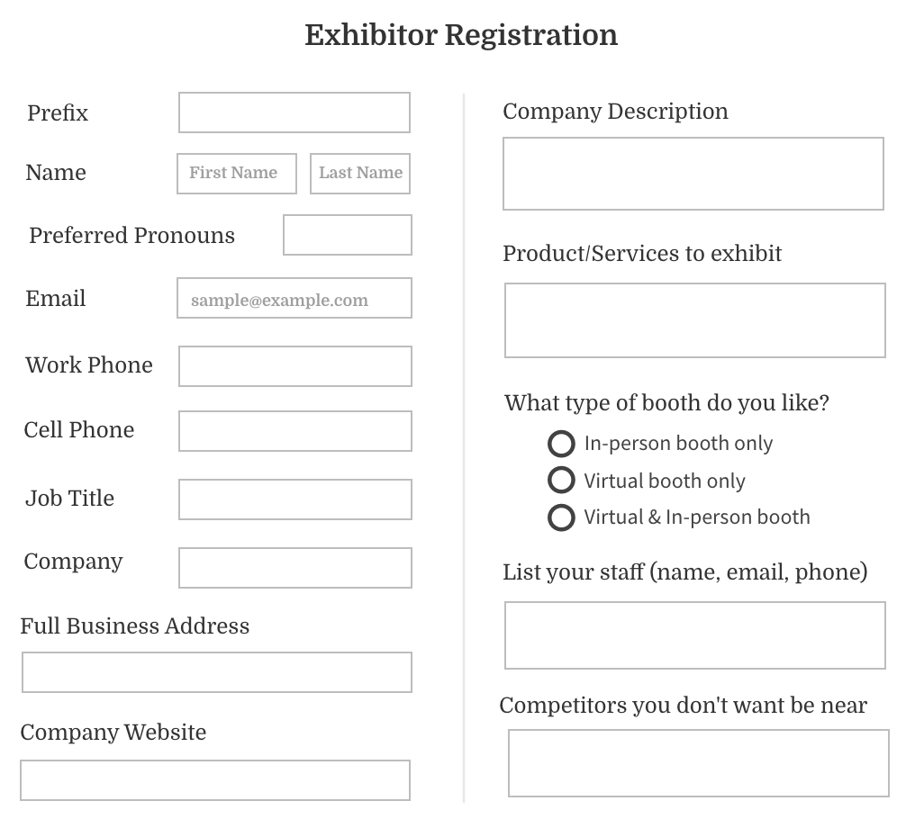

Q:2- Create a html form and while submitting the button show a div and change its content depending upon the value you have selected.

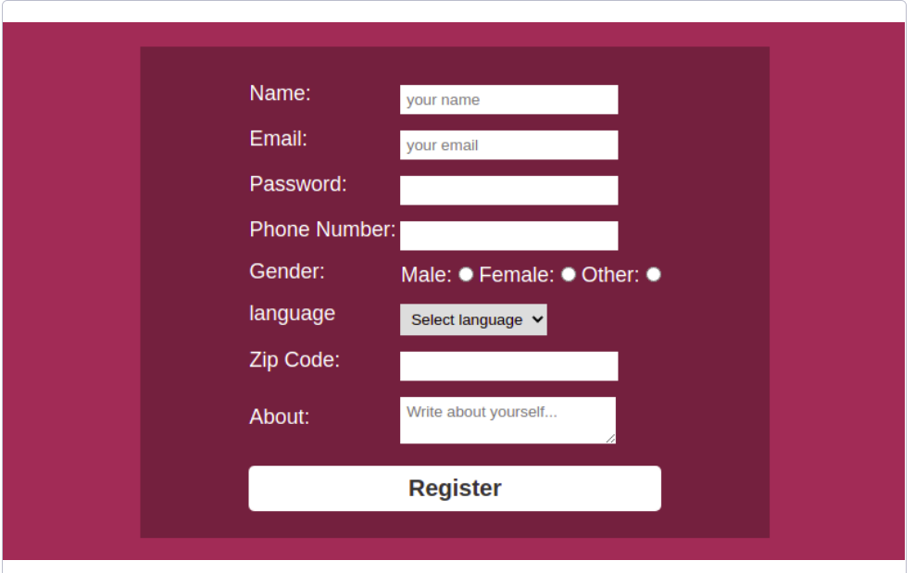

Here, the language you have to read from a json file using fetch() api.

Q-3:

Create a page like this below.

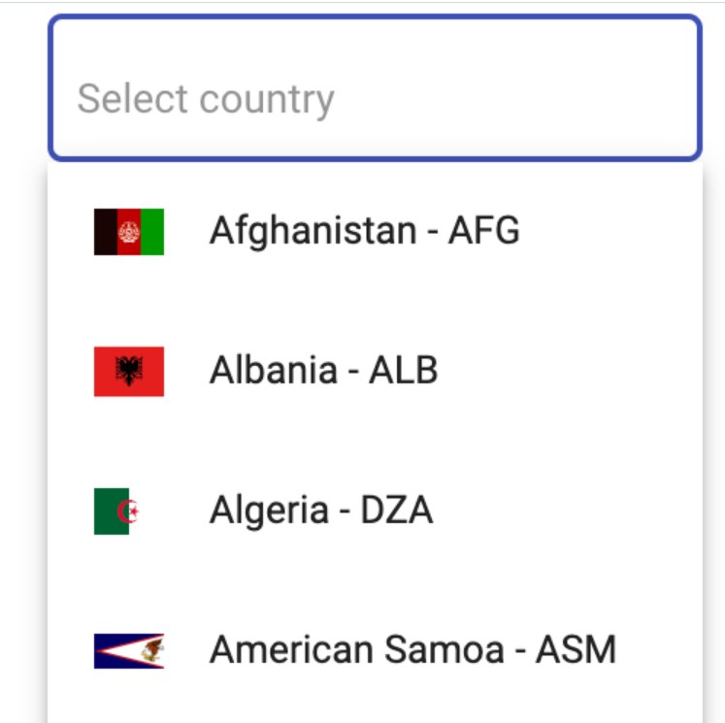

Here use your fetch() api to call this URL.

//https://restcountries.com/v3.1/all

4. Here it will display the flags of all the country, Now you will click on the flag to get the details of that country.



5. Create a simple calculator which can perform arithmetic operations such as +, -, *, / on two integer operands.

**Requirements**

1. The page must contain two **text** type input fields to accept **operands** and **radio** buttons to input an **operator**.
2. By default **'+'**must be checked. On clicking the '**Calculate**' button, the arithmetic operation must be performed and **result** must be rounded off to 3 decimal places and displayed in **green color.**
3. Both the operands must be provided as input. Otherwise on clicking the 'Calculate' button, an error message must be displayed in red as **"Input all values"**
4. The operands must contain only numerical values. Otherwise on clicking the '**Calculate**' button, an error message **"Operands can only be digits"** should be displayed in red
5. Make sure that user does not divide a number by zero. If the user tries to divide a number by zero, then display error message **"Cannot divide by 0"** in red
6. If result goes beyond -100000 to 1000000, an error instance with message **"Result out of bounds"**must be thrown.